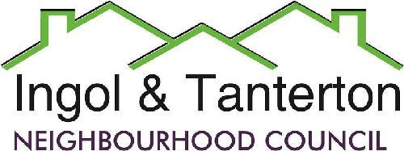
Gill Flynn - Clerk and RFO
Email: ingoltantertonnc@hotmail.co.uk
Agenda

All Neighbourhood Councillors are hereby summoned to the meeting of
Ingol and Tanterton Neighbourhood Council on Wednesday 4th February 2026 at 7.15pm
at Tanterton Village Centre.

1.To receive apologies.

2.To receive declarations of interest.

3.To approve the minutes of the meeting held on Wednesday 7th January 2025.

4.Public participation.

5.To consider planning applications, reports and matters.

6.Finance.
Expenditure
BACS | MB Landscaping | Lengthsman basic | £624.00
BACS | Gill Flynn – clerk | Monthly expenses | £38.27
DD | British Gas | Cottam Gate electrics | £34.92
DD | EasyWebsites | Domain, hosting and emails | £56.76
BACS | HMRC | PAYE / NI/ Employment contributions | £275.83
BACS | Nurture | Monthly grass cutting schedule | £509.20
BACS | LALC | Training Cllr Grimshaw | £35.00
BACS | Tanterton Village Centre | Grant | £6250.00

7.To consider the lengthsman’s update and schedule of works.

8.To consider and approve the precept amount for 2026-2027.

9.To consider the proposals from the Area Enhancement Committee.
- Tanterton Village Shops
- New noticeboard for Ingol West Ward
- Dovedale play area

10.To consider the update on the following:
- Teen shelter siting
- Removal of trees and bushes

11.Reports and correspondence (information only).
Tanterton Hall Road bus shelter update.

12. Date and time of next meetings.

